GREEKSOFT RESTAPI

Introduction:
Greek API is a REST-based trading API designed to help you build and integrate your own trading or investment platform with our system. With this API, you can place real-time orders, track open positions, manage your portfolio, and much more. It empowers you to create a customized trading experience with your own innovative features.

Greek REST API Products:
- Order Management API
- Order Placement API
- Risk Management API
- Admin API
- Strategy Finder & Strategy Builder API
- Option Chain API
- Margin Calculation API

Admin Side Requirements:
- In the Admin panel, under the 'User Management' section, enable 'IBT' and set the secondary password to: a@1111111111.
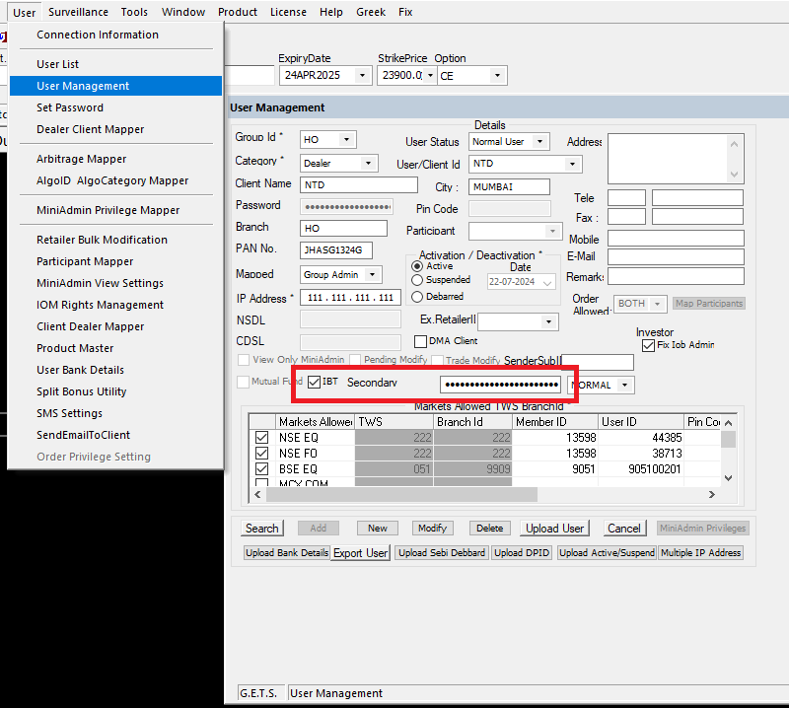

- In the 'Market Allowed' section, enable the 'Automated' option.
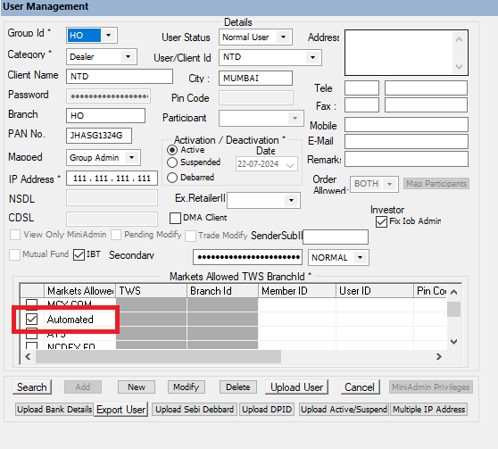

- In Admin > User > Arbitrage Mapper: Map the RESTAPI product to the specific user.
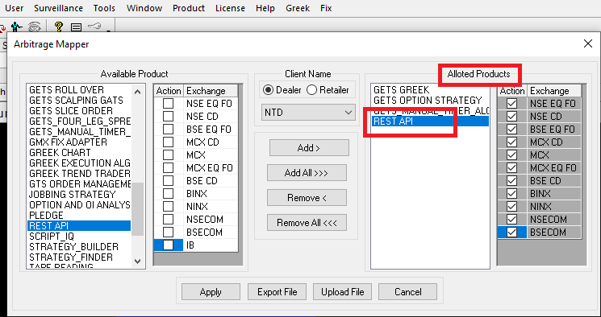

- Capture and share screenshots of the User Management and Market sections (with 'Automated' enabled) with the GreekSoft Support Team for further ID creation.
Support Email: supportteam@greeksoft.co.in

Server Side Requirements:
In the CTCLManager.ini file, include the following flags for REST API setup:
[DBSettings]
Config\isEnableIris=true — enables database settings

[IBT]
Enable_Iris=true — required for enabling fund settings
EnableRestcpp=true — required for REST API

Rest_API_port=3333 — for all REST request-responses
Rest_webApolloSocket_port=8082 — for WebSocket Apollo (or 3031)
Rest_webSocket_port=8085 — for WebSocket Iris (or 3032)

ValidateSessionFromDB=true — internal validation

app_version_no=1.0.1.10
company_name=Your_Broker_Name
isBASE64=true
isSecure=false — disable SSL certificate (use HTTP instead of HTTPS)

Broadcast IP and Port Settings: (below are dummy ip/port)
- NSE Broadcast: IP = 192.168.207.92, Port = 9981
- NFO Broadcast: IP = 192.168.207.92, Port = 9996
- BSE Broadcast: IP = 192.168.204.17, Port = 9987
- BCD Broadcast: IP = 192.168.204.17, Port = 9981
- BFO Broadcast: IP = 192.168.204.17, Port = 9984

Preferred Indexes:
- preferredIndex1 = Nifty_50
- preferredIndex2 = Nifty_Bank
- preferredIndex3 = Sensex

WebSocket Configuration (Optional):
To enable WebSocket support, include the following in the INI file:
- websocket_apollo_ip = broker_server.ip
- websocket_apollo_port = 8082
- websocket_iris_ip = broker_server.ip
- websocket_iris_port = 8085
- websocket_static_ip = broker_server.ip

Postman (Testing Purpose):
- Please download Postman, an open-source tool used for API testing, and log in using your Gmail ID.
- Import the provided collection into Postman.

- Session Token Request – This request will generate an authorization token, which must be included in all subsequent API requests to authenticate the user ID.
Url : http://greekapi.greeksoft.in:3001/auth/greek/sessiontoken

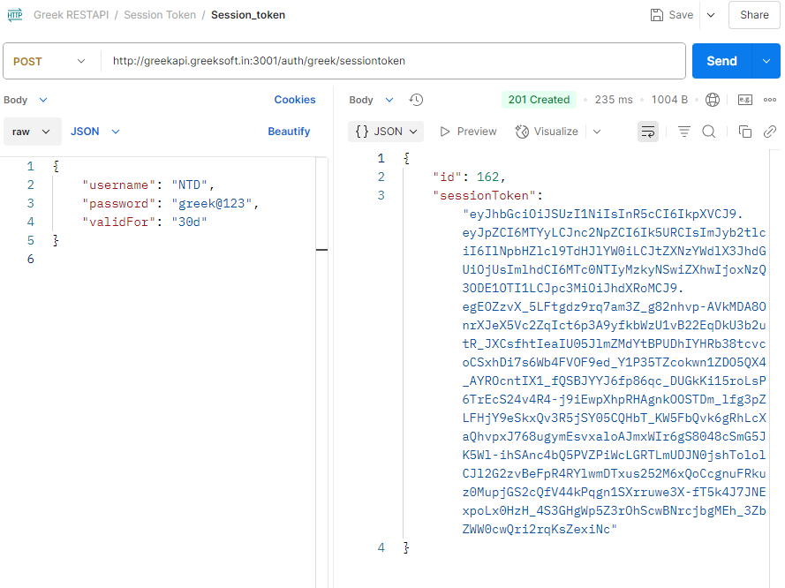

- GetLoginInfo – This should be the first request executed when using the API. It authenticates access to the Greek API and returns a “gcid” in the response, which is required for all further API interactions.
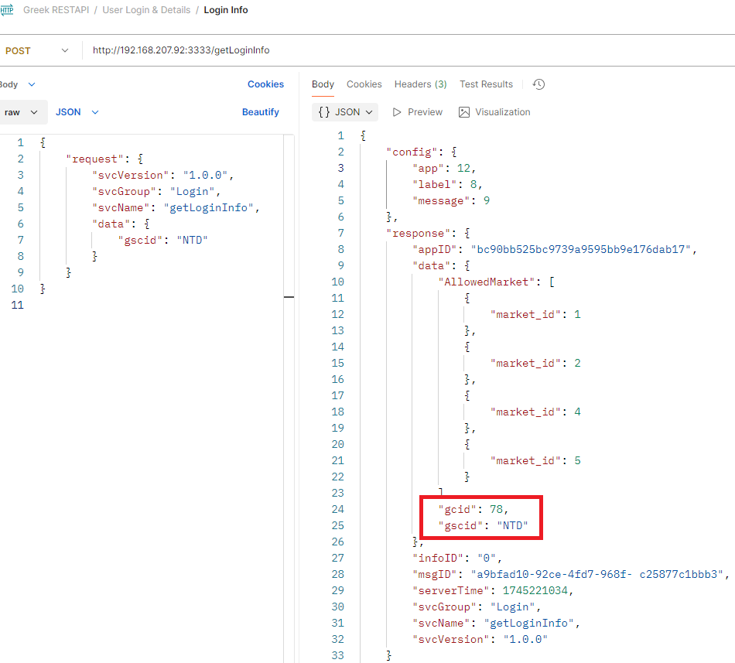

Important Points to Note
- The default message rate for each new ID is set to 5. This can be increased based on the client’s requirements.
- The SessionToken has a defined validity period. Please ensure the duration is set appropriately. Note that generating a new session token will invalidate the previous one.
- The GCID received from the GetLoginInfo request is not constant and may change. Please ensure your implementation handles this dynamically.
- The SessionID returned from the jloginNew request is also not fixed. A new SessionID is generated with every request, and the previous one becomes invalid.
- For WebSocket connections (IRIS or APOLLO), if there is no activity for 15 minutes, the connection will be terminated. To keep the session alive, it is recommended to send periodic heartbeat requests.
- Ensure proper handling of mandatory and optional fields as per the requirements. Please refer to the attached Excel file for detailed field information.

GREEKSOFT Python Library (PyPi)

Overview
GreekAPI is a Python library that provides access to financial data and trading functionalities. It offers a set of REST API endpoints to interact with market data, execute trades, and retrieve account information.

Installation
To install GreekAPI, use pip. Make sure you have python installed on your system
In cmd, type:

pip install greekapi

Importing the Library and Authentication

To use the library, import the Greek_API class from greekapi and authenticate with your credentials:

from greeksoft import GreekAPI

# User credentials
username = "username" # e.g., "AB1023"
session_pwd = "session_pwd" # e.g., "greek@123"
user_pwd = "user_pwd" # e.g., "a@1111111111"
procli = "2" # Client ID (2 for client, 1 for retail)
ac_no = "ac_no" # For retail ID, pass account number

# Authenticate with provided credentials
api = GreekAPI(username, session_pwd, user_pwd, procli, ac_no)

You can refer the below link for more details regarding Greek PyPi
URL : https://pypi.org/project/greeksoft/

